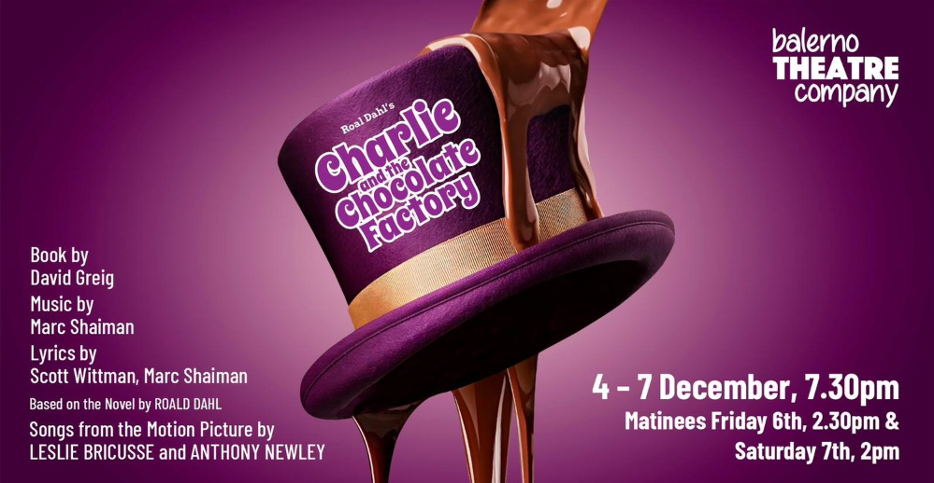

Pre-Audition Pack

Open Evening
Date | Time | Venue
Thursday 25th April | 7.30pm-9.15pm | Balerno High School  Drama Studio
This is an excellent opportunity for potential cast members to find out more about the company, meet recent and returning cast members and learn about the production itself and the audition process.

You will be taught a song and dance to perform at your audition and given an overview of the show, the characters and what to expect if you are successful.
Under 16’s must be accompanied by a parent/guardian.
Whilst attendance is not mandatory, it is highly recommended.
If you cannot make it to the open evening, you can still book an audition slot and access materials on the website.

Who can audition?
This production will require a cast of adults and children.
Children must be aged 7+ on date of audition.
No past experience is necessary.
Auditionees must be able to commit to the rehearsal and performance dates detailed below.

What can you audition for?
When you book your audition slot we will ask you to let us know what roles you would like us to consider you for. You can select any or all of the following options:
Ensemble/Chorus
We hope to cast an ensemble of adults and children for this production. Depending on the number of auditionees, we may consider double-casting the children’s ensemble. In this case, each child cast would perform 3 or 4 of the shows. The adult ensemble cast will perform all 7 shows.
Principal/Lead Role
A full list of these roles are available on the website.

Featured Dancers
If you are cast as a featured dancer you will also perform as part of the ensemble.

Book an Audition
Auditions will be accepted by appointment only - you can submit your Audition Booking Form via our website.

Audition Dates
Once you have submitted your audition form, you will be emailed with an audition slot date and time on either of the following:
Tuesday 30th April  Thursday 2nd May | 6.30pm – 9.00pm  6.30pm – 9.00pm

What will happen at your audition?

Audition Panel
Director Fraser Grant
Assistant Director Jessica Russell
Producer Lauren Hendrie
Musical Director James McCutcheon
Choreographer Darren Johnson
Committee Representative Anne Mackie

The audition panel will make every effort to help you feel relaxed and perform at your best during the audition.
You will be auditioned in groups of 4-5.
Whilst the panel will be looking for a demonstration of singing, dancing, and overall performance abilities, performing is all about fun so bring plenty enthusiasm, energy and your best smiles!
Applicants should attend 10 minutes before their Audition (which intend to take approximately 15 minutes) and should wear something comfortable.

We will take a picture of you (if consent given on audition form) so that we can remember faces/names but this photo will be deleted as soon as all auditions are over.

Ensemble Auditions
You will be expected to perform the ensemble audition song and dance as a group and sing a few lines of the audition song on your own.

Featured/Principal Role Auditions
You will be asked to perform the ensemble audition dance as a group.
We will ask you to perform the audition dialogue for your preferred role.
You will also be asked to sing the ensemble audition song
We may ask you to return for a further audition on Thursday 7th May for our call backs.
This will be more of a workshop based audition where you will be working along side other auditionees. You may also be asked to sing a specific song for the role you are going for, this will be provided by the Musical Director at the open evening.
Featured Dancer
You will be expected to perform the ensemble audition song and dance as a group and sing a few lines of the audition song on your own.

Audition Material
The audition material will be available on our website after the Open Evening on 25th April. This will include:

- Lyrics for the Ensemble Audition Song
- Music track for the Ensemble song
- Video of the Audition Dance
- Audition Dialogue for Principal/Featrures Roles

Where possible, we will cast roles without calling back for a second audition. Applicants invited for a second audition will be notified by email shortly after Thursday 2nd May.

It is anticipated both successful and unsuccessful applicants will be notified by email no later than Friday 17th May.

Please note – the Director’s decision is final and there is no appeal process.

Should the applicant be unable to attend their Audition, they should notify the Secretary as soon as possible by using the ‘Contact Us’ link on our website or emailing secretary@balernotheatrecompany.co.uk.

Subscription Fees
Successful applicants are required to pay a £125 Subscription Fee for their participation in Charlie and the Chocolate Factory.

Acceptance of role will be confirmed only by payment of the full amount of £125 by Friday 31st May. If we do not receive full payment by this date, the applicant’s role may be offered to another cast member.

Rehearsals
Rehearsals will usually take place in Balerno High School but on rare occasions we may need to use different rehearsal venues located within the Currie/Balerno/Juniper Green area.

Rehearsal Dates
Pre-Summer Rehearsals:
Every Thursday from 6th June – 27th June
Post-Summer Rehearsals:
Every Tuesday & Thursday from 15th August – 28th November

Rehearsal Times
7pm-9:15pm

NOTE: Primary school-aged children will usually finish at 8.15pm although there may be some exceptions

Whilst cast members will not be expected to attend every rehearsal, we ask you not to audition if you cannot commit to regularly attend rehearsals on Tuesdays and Thursdays.

Saturday Rehearsals:

We hold 2 all day Saturday Rehearsals – one in October & one in November. These all day rehearsals are essential to do full run through of the show. We will confirm these dates in due course.
Theatre ‘Get-In’ & Band Call:
Date | Time | Venue
Sunday 1st December | 10am-6pm | Church Hill Theatre

Technical Rehearsal:
Date | Time | Venue
Monday 2nd December | 6pm | Church Hill Theatre

Dress Rehearsal:
Date | Time | Venue
Tuesday 3rd December | 6pm | Church Hill Theatre

Performance Dates & Curtain up times
Date | Time | Venue
Wednesday 4th December | 7.30pm | Church Hill Theatre
Thursday 5th December | 7.30pm | Church Hill Theatre
Friday 6th December | 2.30pm & 7.30pm | Church Hill Theatre
Saturday 7th December | 2.00pm & 7.30pm | Church Hill Theatre

